[Team-6]

Requirement specification document of Personal Portfolio Web Application.

Each page and its features represented in a simple and understandable way.

BRS Documentation

档标题]

**Personal Portfolio**

● Login Page

● Registration Page

● Team Portfolio Page

● Home Page

● About me Page

● My Portfolio Page

● My Blogs Page

● Contact me Page

**OBJECTIVE :**

In the 1930s, before the advent of portfolio theory, people still had "portfolios." However, their perception of the portfolio was very different, as was the primary method of building one. In 1938, John Burr Williams wrote a book called The Theory of Investment Value that captured the thinking of the time: the [dividend discount model](https://www.investopedia.com/terms/d/ddm.asp). The goal of most investors was to find a good stock and buy it at the best price.

Whatever an investor's intentions, investing consisted of laying bets on stocks that you thought were at their best price. During this period, information was still coming in slowly and the prices on the [ticker tape](https://www.investopedia.com/terms/t/tickertape.asp) didn't tell the entire story. The loose ways of the market, although tightened via accounting regulations after [the Great Depression](https://www.investopedia.com/terms/g/great_depression.asp), increased the perception of investing as a form of gambling for people too wealthy or haughty to show their faces at the track.

**1.Introduction**

**1.11Purpose**

* 1. Purpose

Personal Portfolio—Simply for your personal use. This portfolio is a collection or a scrapbook of things that interest you. This portfolio could be used as a stepping block towards understanding who you are and where would like to be in the futur

• Letters of reference

• Resume or Vitae

• Lists of accomplishments

• Samples of work (e.g., items produced on internship or co-op experiences,class projects, items produced from previous job).

## **Project Scope**

Many of our clients ask if they need to specifically define what projects, products or offerings should be included in their product portfolios and what should be left out. Leading portfolio management practices advocate the need for defining portfolio inclusion criteria. Why is it necessary to define your portfolio’s scope? There are at least two compelling reasons: clear portfolio ownership and an enhanced focus on crucial projects.

**2.1) LOGIN PAGE**

This page should let only the registered users into the main page of the portfolio web application.

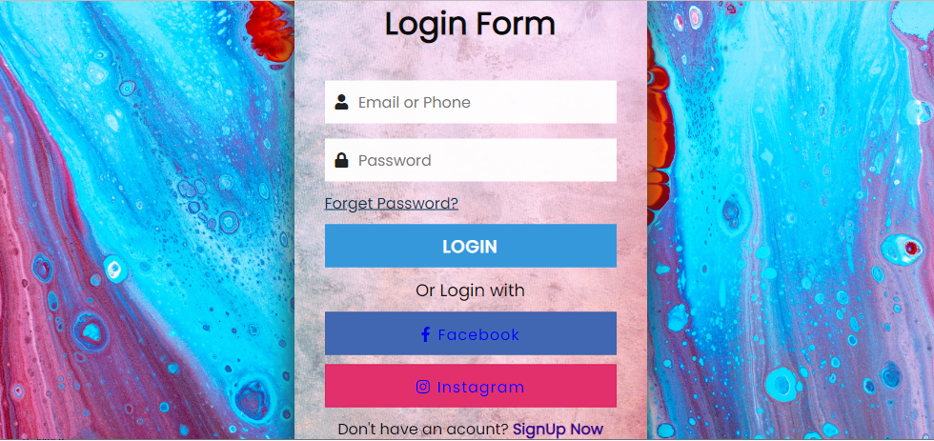

**Required Fields :**

* Login fields
* Register as New User
* Link for Registering

**2.2 REGISTRATION PAGE**

This page in Portfolio personal information should let the user to Register his details with portfolio login a web application and proceed with further steps.

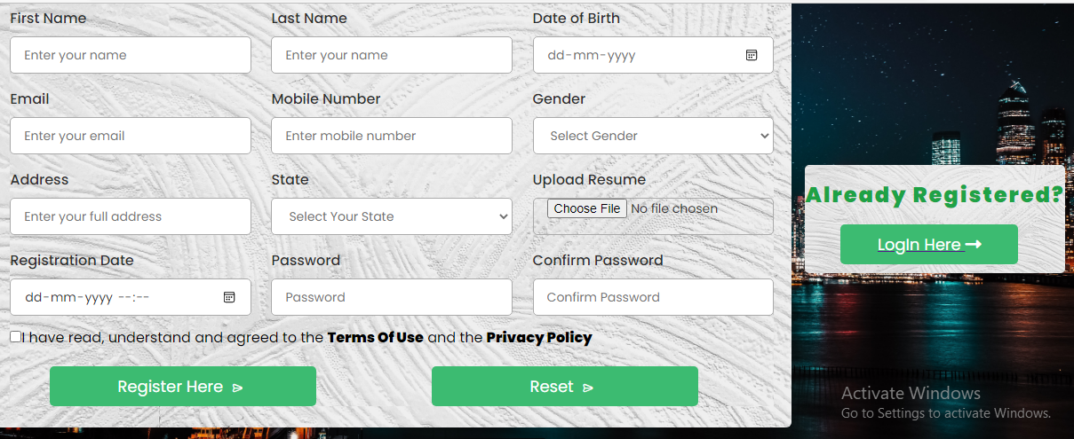

**Required fields:**

1. Personal details of user
2. Contact Details of user
3. Valid username for Login
4. Valid password of Login
5. Terms and conditions

**REQUIREMENTS:**

* First name textfield should follow first character uppercase and remaining lowercase letters.
* Last name textfield should follow first character uppercase and remaining lowercase letters.
* Mobile textfield maximum length is 10 digits.
* Date of birth should select in calender field
* Gender using drop down box we should select gender
* Resume for uploading resume should choose file.
* State for choosing we use dropdown field
* Username textfield should consists of combination of uppercase and lowercase letters.
* The maximum length of username is 8-16 characters.
* Password textfield should consists of combination of uppercase and lowercase and numerical.
* The maximum length of password is 8-16 characters.

**2.3) MAIN PAGE :**

This page Should display the details of group persons and other options to perform other actions such as hire me and,About me.

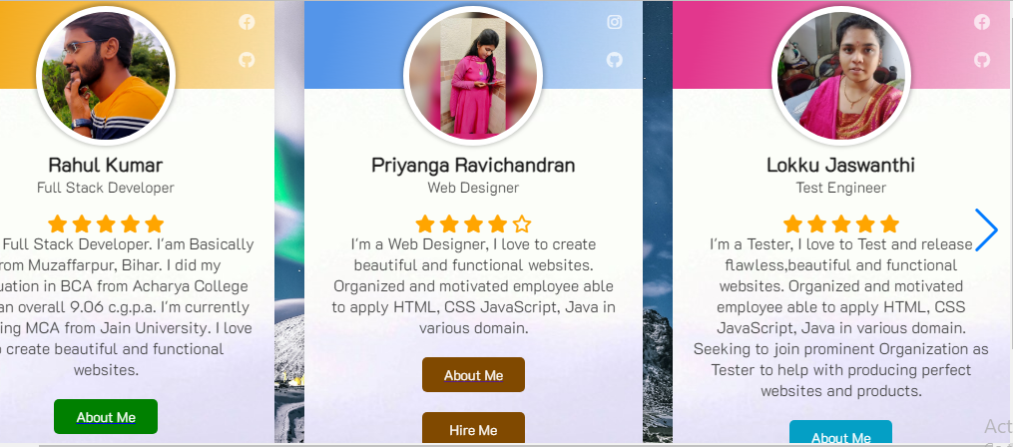

**Required fields :**

* A Brief information about persons in portfolio

**HOME PAGE:**

In home page we can change the colour theme

**ABOUT ME:**

The details about me like project completion, year of exeperience, happy clients, skills, customer review and then my education details.

**Contact me:**

Here anyone can contact me by sending message using mail id, name,and then subject.

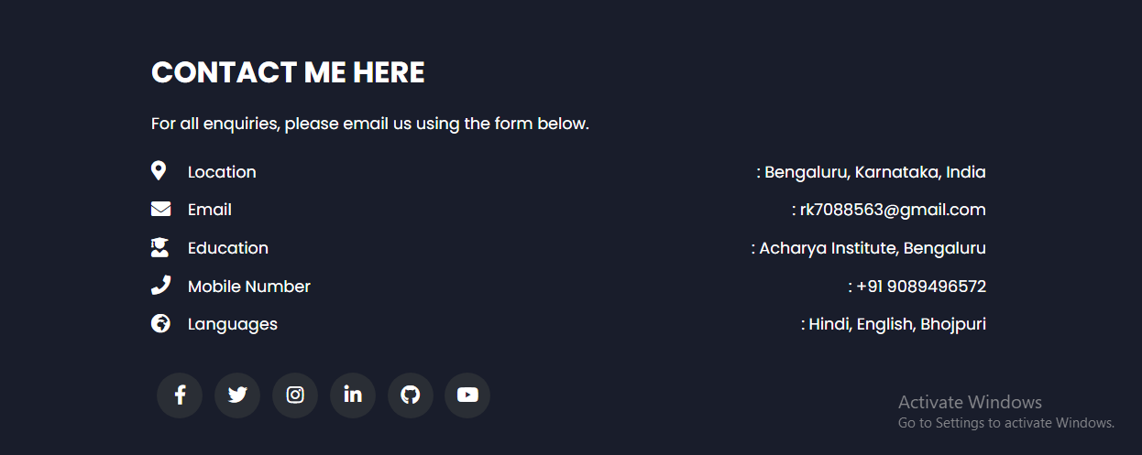

My social platforms to contact me like, github, linkedin, instagram and youtube.

**My blogs:**

Here I information gathered to create a website .

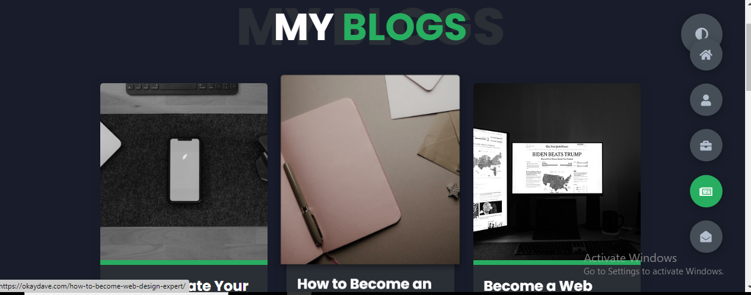

---------------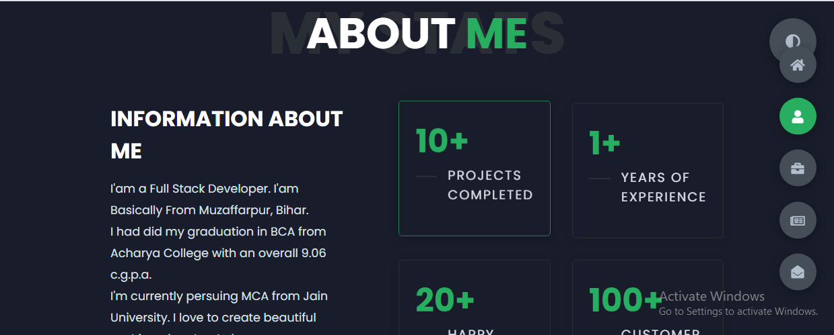



**Required fields:**

1. Personal details of user
2. Contact Details of user
3. Valid username for Login
4. Valid password of Login
5. Terms and conditions

**REQUIREMENTS:**

* First name textfield should follow first character uppercase and remaining lowercase letters.
* Last name textfield should follow first character uppercase and remaining lowercase letters.
* Mobile textfield maximum length is 10 digits.
* Date of birth should select in calender field
* Gender using drop down box we should select gender
* Resume for uploading resume should choose file.
* State for choosing we use dropdown field
* Username textfield should consists of combination of uppercase and lowercase letters.
* The maximum length of username is 8-16 characters.
* Password textfield should consists of combination of uppercase and lowercase and numerical.
* The maximum length of password is 8-16 characters.

**2.3) MAIN PAGE :**

This page Should display the details of group persons and other options to perform other actions such as hire me and,About me.

registere

**Required Fields :**

* Login fields
* Register as New User
* Link for Registering

**2.2 REGISTRATION PAGE**

This page in Portfolio personal information should let the user to Register his details with portfolio login a web application and proceed with further steps.



**2.1) LOGIN PAGE**

This page should let only the registered users into the main page of the portfolio web application.

**Login**